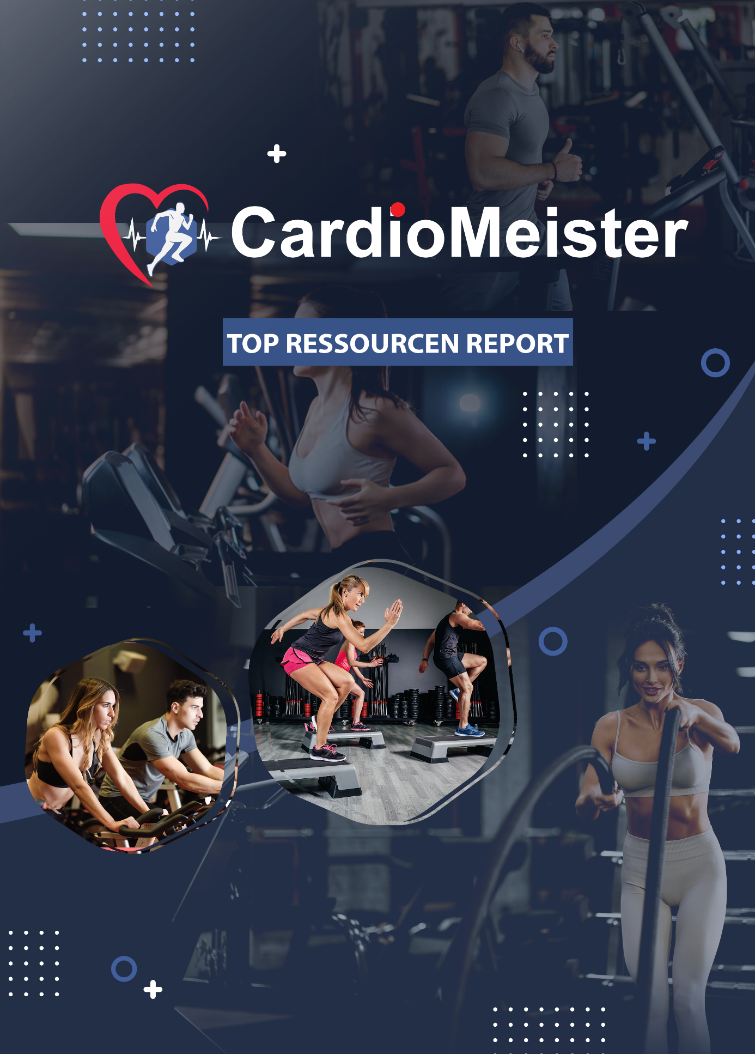

Cardio Meister
Video
✓ https://www.youtube.com/watch?v=8sAWJdQtGbE
✓ https://www.youtube.com/watch?v=8JpKOczCPHU
✓ https://www.youtube.com/watch?v=qWy_aOlB45Y
✓ https://youtu.be/W5IiasNutB8
✓ https://www.youtube.com/watch?v=CBWQGb4LyAM

Tools
✓ https://www.verywellfit.com/cardiovascular-fitness-1230820
✓ https://www.healthline.com/health/fitness-exercise/cardio-exercises-list
✓ https://www.womenshealthmag.com/fitness/a22995307/cardio-exercises/
✓ https://www.mensjournal.com/health-fitness/back-basics-11-ways-build-yourbest-cardio-workout/

Training
✓ https://www.unionrestaurant.com/4-reasons-why-fitness-is-important/
✓ https://www.heart.org/en/healthy-living/fitness/fitness-basics/why-is-physicalactivity-
so-important-for-health-and-wellbeing
✓ https://www.mayoclinic.org/healthy-lifestyle/fitness/in-depth/exercise/art-
20048389
✓ https://www.betterhealth.vic.gov.au/health/healthyliving/physical-activity-itsimportant
✓ https://www.healthstatus.com/health_blog/wellness/the-importance-ofphysical-fitness/

Blogs
✓ https://www.acefitness.org/education-and-resources/lifestyle/blog/
✓ https://detailed.com/fitness-blogs/
✓ https://www.developgoodhabits.com/fitness-blogs/
✓ https://blog.feedspot.com/fitness_blogs/

Forums
✓ https://www.dexafit.com/blog2/top-20-health-and-fitness-blogs-2018
✓ https://www.stylecraze.com/articles/top-fitness-blogs/
✓ https://blog.movegb.com/why-exercise-is-never-a-waste-of-time
✓ https://masterysky.com/2018/06/05/fitness-definitely-not-a-waste-of-time/

Infographics
✓ https://www.openfit.com/what-is-cardio
✓ https://diet.mayoclinic.org/diet/move/cardio-101
✓ https://www.healthline.com/health/cardio-exercises-at-home
✓ https://www.womenshealthmag.com/fitness/a22995307/cardio-exercises/
✓ https://www.besthealthmag.ca/best-you/fitness/what-is-cardio-and-why-do-weneed-it/

